# Step 1 - Understanding the Model

* If a house has 1 more bedroom than another with the same square footage and the same number of bathrooms, how much more should I expect to pay? Why?
  + The one additional bedroom would result in an additional $52613.90 in price. The formula created by the regression determined that the coefficient for a bedroom is 52,613.90, so for every increase in the number of bedrooms the price will increase by the amount of the coefficient.
* If you were interested in a 1 bedroom house with 2 bathrooms and is 1400 square feet, how much would the model predict you should pay for it?
  + The formula is price = 51880.41 + 44.72 * square feet + 52613.9 * bedrooms + 27513.48 * bathrooms
    - so now we will plug in the values for the different variables.
    - Price = 51880.41+ 44.72 * 1400 + 52613.9 * 1 + 27513.48 * 2
    - Price = 222129.27

# Step 2: Visualize the Data

* Plot 1 - Plot the data for the houses where you know the price in the database, with bedrooms on the x-axis and price on the y-axis.
* Plot 2 - Plot the data for the houses for which you are predicting prices with bedrooms on the x-axis and predicted price on the y-axis.
  + Note: You can also plot both sets of data on the same chart in different colors.
* What strikes you about this comparison? After seeing this plot, do you feel confident in the model’s ability to predict prices?

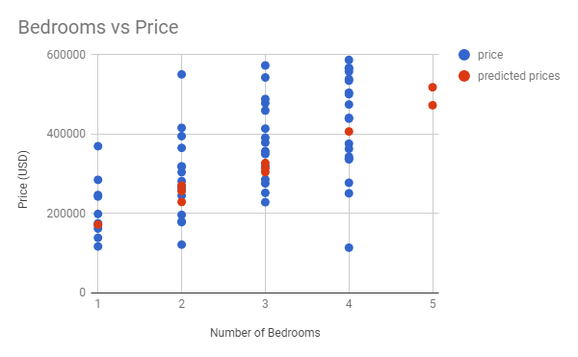

The predicted prices are more compact than the actual data is. This is because we are not accounting for everything that effects prices. There are many more things than bedrooms that effect it. We had bathrooms and sq_ft factored in to our formula but not even that will account for all the variation. For instance this formula might look very different depending on the city you are training the model on.

After looking at this plot the model appears on average to predict the prices ok, but it can be very off for certain houses. There appears to be an outlier home with only 2 bedrooms but sold for almost $600,000.00. While the formula may not be accurate for an individual house, it should do a decent job at predicting the price we should pay for several house at once since it on average looks representative.

# Step 3: Make a Recommendation

*Answer the following questions:*

* What price do you recommend the investment company to bid? Please explain how you arrived at that number.
  + I recommend a bid of $2,617,766.19. I arrived at this number by using a formula from the regression model provided that was based on previous home sales and applied it to the houses that were up for bid. I then factored in the margin the investors were looking for which was 20% so I multiply the predicted amount 3272207.74 by .80 to get the final predicted bid of $2,617,766.19